## Escala KDQOL:

Las medias de los puntajes en cada uno de los dominios se presentan en la siguiente tabla. Puede verse que hay un incremento en las medidas de calidad de vida en todos los dominios, aunque poco marcados en los factores SF-12 Physical y SF-Mental.

|  |  |  |  |  |
| --- | --- | --- | --- | --- |
|  |  | Moment | | |
|  |  | 1; N=971 | 2; N=808 | 3; N=642 |
| Symptom/Problem | mean | 78.6 | 81.0 | 81.5 |
| sd | 15.8 | 15.4 | 14.9 |
| Effects of kidney disease | mean | 69.7 | 72.8 | 75.1 |
| sd | 22,3 | 22.0 | 21 |
| Burden of kidney disease | mean | 46.2 | 48.9 | 50.2 |
| sd | 27,5 | 29.9 | 32.3 |
| SF-12 Physical | mean | 41.1 | 41.0 | 41.7 |
| sd | 11.1 | 11.2 | 10.5 |
| SF-Mental | mean | 51.1 | 51.9 | 52.3 |
| sd | 11,6 | 11.3 | 11.1 |

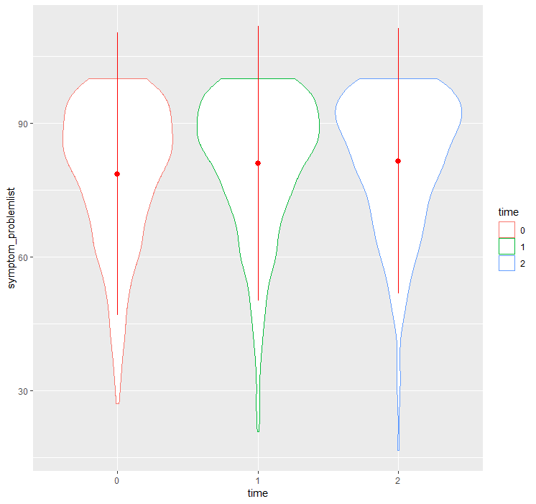

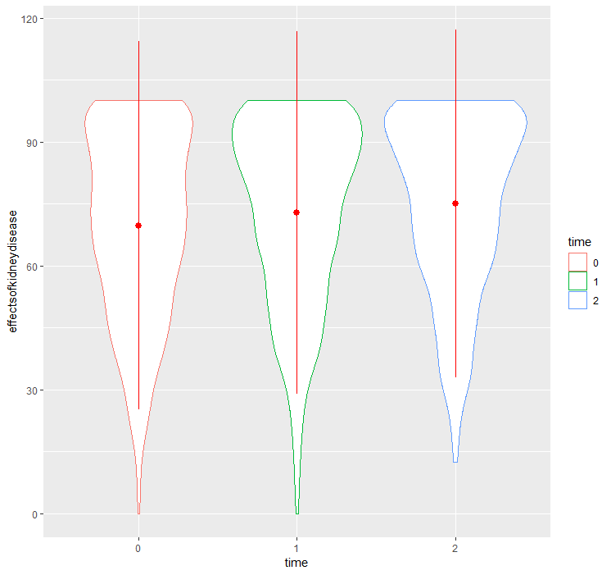

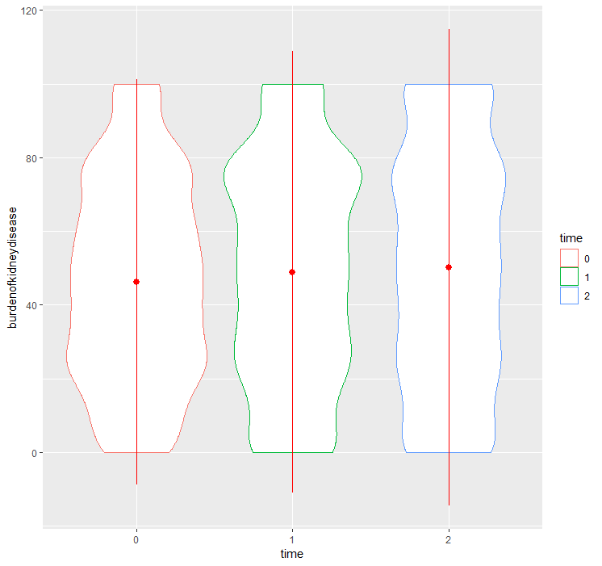

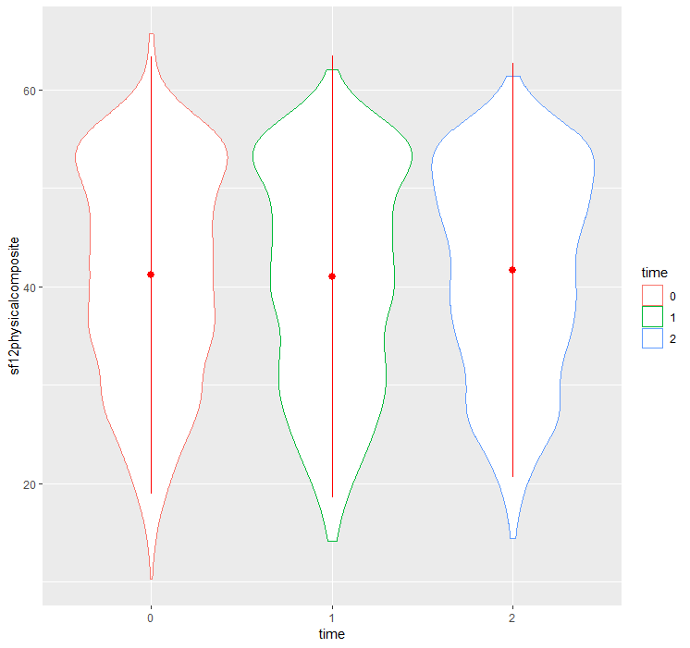

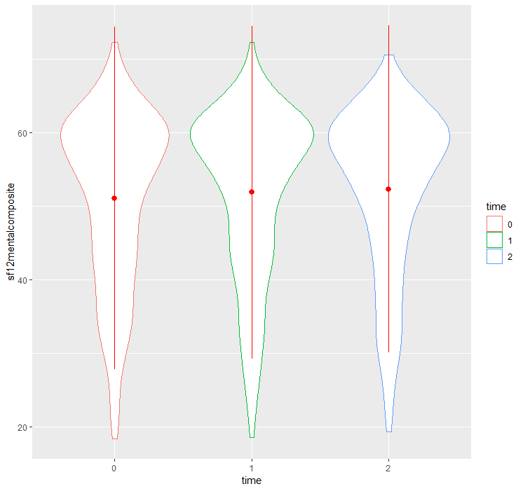

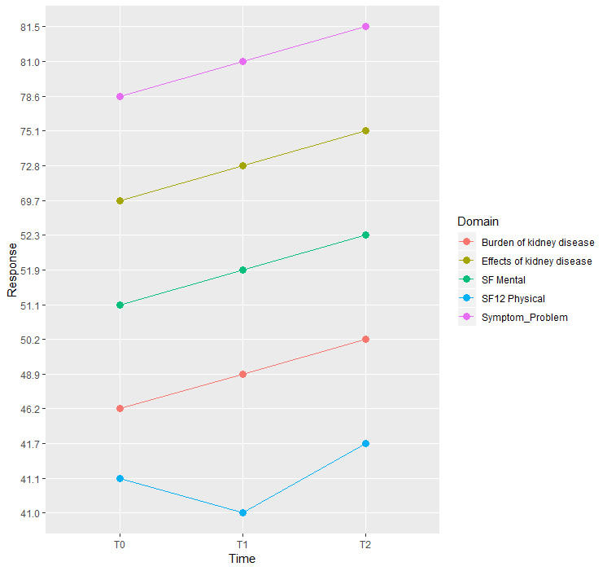

Se evaluó si el anterior cambio de las cinco dimensiones en el tiempo es estadísticamente significativo; para esto se utilizaron pruebas de ANOVA de medidas repetidas, independientes para cada uno de los factores. Los resultados se muestran a continuación:

1. Dominio “ Symptoms/Problems”:

. anova symptom_problemlist newid moment, repeated( moment)

Number of obs = 2422 R-squared = 0.7650

Root MSE = 9.75328 Adj R-squared = 0.6040

Source | Partial SS df MS F Prob > F

-----------+----------------------------------------------------

Model | 444942.782 984 452.177624 4.75 0.0000

|

newid | 440872.831 982 448.954003 4.72 0.0000

moment | 3601.28922 2 1800.64461 18.93 0.0000

|

Residual | 136696.777 1437 95.1264975

-----------+----------------------------------------------------

Total | 581639.559 2421 240.247649

Between-subjects error term: newid

Levels: 983 (982 df)

Lowest b.s.e. variable: newid

Repeated variable: moment

Huynh-Feldt epsilon = 0.9798

Greenhouse-Geisser epsilon = 0.9779

Box's conservative epsilon = 0.5000

------------ Prob > F ------------

Source | df F Regular H-F G-G Box

-----------+----------------------------------------------------

moment | 2 18.93 0.0000 0.0000 0.0000 0.0000

Residual | 1437

----------------------------------------------------------------

Hay diferencias significativas en el tiempo (F(2, 1437)=18.93; p<0.0001)

. anova effectsofkidneydisease newid moment, repeated( moment)

Number of obs = 2421 R-squared = 0.7234

Root MSE = 15.0029 Adj R-squared = 0.5339

Source | Partial SS df MS F Prob > F

-----------+----------------------------------------------------

Model | 845427.365 984 859.174152 3.82 0.0000

|

newid | 833944.518 982 849.23067 3.77 0.0000

moment | 10169.514 2 5084.75701 22.59 0.0000

|

Residual | 323226.261 1436 225.087925

-----------+----------------------------------------------------

Total | 1168653.63 2420 482.914722

Between-subjects error term: newid

Levels: 983 (982 df)

Lowest b.s.e. variable: newid

Repeated variable: moment

Huynh-Feldt epsilon = 0.9688

Greenhouse-Geisser epsilon = 0.9669

Box's conservative epsilon = 0.5000

------------ Prob > F ------------

Source | df F Regular H-F G-G Box

-----------+----------------------------------------------------

moment | 2 22.59 0.0000 0.0000 0.0000 0.0000

Residual | 1436

----------------------------------------------------------------

Hay diferencias significativas en el tiempo (F(2, 1436)=22.59; p<0.0001)

. anova burdenofkidneydisease newid moment, repeated( moment)

Number of obs = 2421 R-squared = 0.7315

Root MSE = 19.9711 Adj R-squared = 0.5476

Source | Partial SS df MS F Prob > F

-----------+----------------------------------------------------

Model | 1560541.94 984 1585.9166 3.98 0.0000

|

newid | 1553789.72 982 1582.27059 3.97 0.0000

moment | 8418.5422 2 4209.2711 10.55 0.0000

|

Residual | 572740.312 1436 398.844228

-----------+----------------------------------------------------

Total | 2133282.25 2420 881.521591

Between-subjects error term: newid

Levels: 983 (982 df)

Lowest b.s.e. variable: newid

Repeated variable: moment

Huynh-Feldt epsilon = 0.9948

Greenhouse-Geisser epsilon = 0.9928

Box's conservative epsilon = 0.5000

------------ Prob > F ------------

Source | df F Regular H-F G-G Box

-----------+----------------------------------------------------

moment | 2 10.55 0.0000 0.0000 0.0000 0.0012

Residual | 1436

----------------------------------------------------------------

Hay diferencias significativas en el tiempo (F(2, 1436)=10.55; p<0.0001)

. anova sf12physicalcomposite newid moment, repeated( moment)

Number of obs = 2417 R-squared = 0.7274

Root MSE = 7.44363 Adj R-squared = 0.5401

Source | Partial SS df MS F Prob > F

-----------+----------------------------------------------------

Model | 211740.509 984 215.183444 3.88 0.0000

|

newid | 211572.935 982 215.451054 3.89 0.0000

moment | 132.099635 2 66.0498173 1.19 0.3039

|

Residual | 79343.6834 1432 55.4076002

-----------+----------------------------------------------------

Total | 291084.193 2416 120.481868

Between-subjects error term: newid

Levels: 983 (982 df)

Lowest b.s.e. variable: newid

Repeated variable: moment

Huynh-Feldt epsilon = 0.9769

Greenhouse-Geisser epsilon = 0.9750

Box's conservative epsilon = 0.5000

------------ Prob > F ------------

Source | df F Regular H-F G-G Box

-----------+----------------------------------------------------

moment | 2 1.19 0.3039 0.3032 0.3032 0.2753

Residual | 1432

----------------------------------------------------------------

No hay diferencias significativas en el tiempo (F(2, 1432)=1.19; p=0.3039)

. anova sf12mentalcomposite newid moment, repeated( moment)

Number of obs = 2417 R-squared = 0.6597

Root MSE = 8.63002 Adj R-squared = 0.4259

Source | Partial SS df MS F Prob > F

-----------+----------------------------------------------------

Model | 206747.654 984 210.109404 2.82 0.0000

|

newid | 206093.758 982 209.871444 2.82 0.0000

moment | 870.391105 2 435.195553 5.84 0.0030

|

Residual | 106651.486 1432 74.4772944

-----------+----------------------------------------------------

Total | 313399.14 2416 129.718187

Between-subjects error term: newid

Levels: 983 (982 df)

Lowest b.s.e. variable: newid

Repeated variable: moment

Huynh-Feldt epsilon = 0.9805

Greenhouse-Geisser epsilon = 0.9786

Box's conservative epsilon = 0.5000

------------ Prob > F ------------

Source | df F Regular H-F G-G Box

-----------+----------------------------------------------------

moment | 2 5.84 0.0030 0.0032 0.0032 0.0159

Residual | 1432

----------------------------------------------------------------

Hay diferencias significativas en el tiempo (F(2, 1432)=18.93; p=0.003)

## Escala DSI.

La escala utiliza dos sistemas de calificación: Uno es un **puntaje global** (overall_pre y overall_post) resultante de sumar el número de ítems reportados como presentes (toma valores entre 0 y 30): básicamente corresponde a un conteo de síntomas; el otro es un **puntaje de gravedad de síntomas** (severity_­pre y severity_post**)** que suma un score asignado a cada uno de los ítems (toma valores entre 30 y 150 ya que cada síntoma presente se puntúa entre 1 y 5).

Los síntomas que incluye la escala se presentan en la siguiente tabla

|  |  |
| --- | --- |
| ISD01 | Estreñimiento/constipación |
| ISD02 | Náuseas |
| ISD03 | Vómito |
| ISD04 | Diarrea |
| ISD05 | Disminución del apetito |
| ISD06 | Calambres musculares |
| ISD07 | Hinchazón en las piernas |
| ISD08 | Falta de aire |
| ISD09 | Mareos/vahídos |
| ISD10 | Piernas inquietas o dificultad para mantener las piernas quietas |
| ISD11 | Adormecimiento/hormigueo en los pies |
| ISD12 | Sensación de cansancio/falta de energía |
| ISD13 | Tos |
| ISD14 | Boca seca |
| ISD15 | Dolor en los huesos o las articulaciones |
| ISD16 | Dolor en el pecho |
| ISD17 | Dolor de cabeza |
| ISD18 | Dolor muscular |
| ISD19 | Dificultad para concentrarse |
| ISD20 | Resequedad de la piel |
| ISD21 | Rasquiña / comezón |
| ISD22 | Sentirse preocupado |
| ISD23 | Sentirse nervioso |
| ISD24 | Dificultad para quedarse dormido |
| ISD25 | Problemas para mantener el sueño |
| ISD26 | Sentirse irritable |
| ISD27 | Sentirse triste |
| ISD28 | Sentirse ansioso |
| ISD29 | Disminución del interés por el sexo |
| ISD30 | Dificultad para excitarse sexualmente |

Descripción de ítems de la escala DSI en línea de base:

N=979

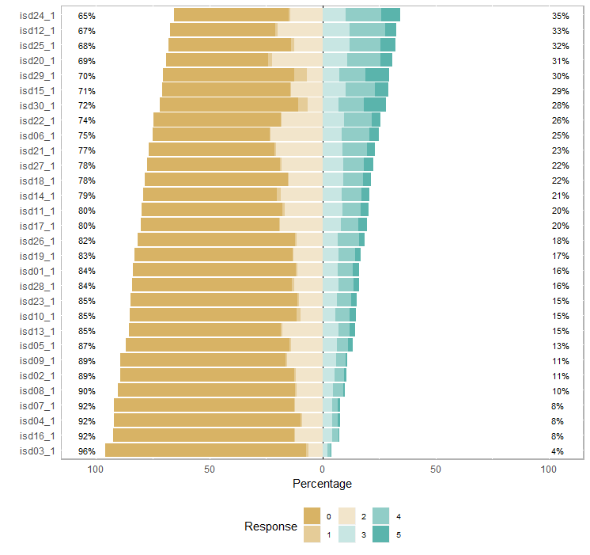

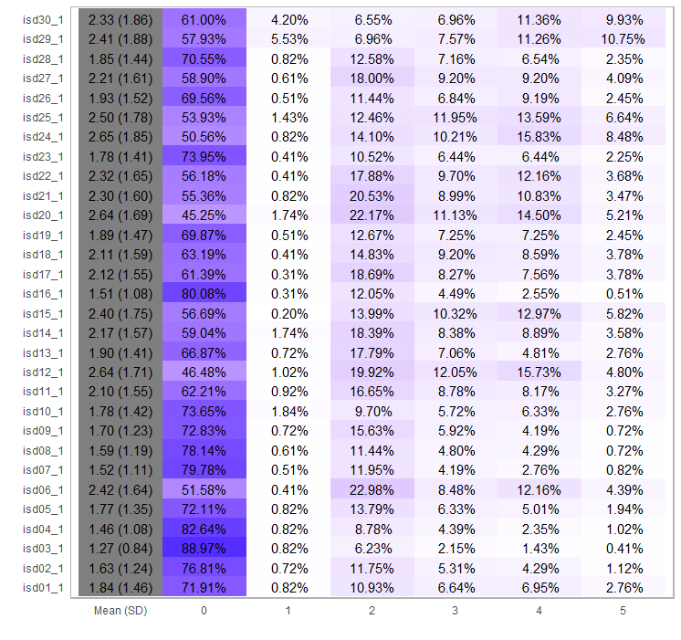

Descripción de ítems de la escala DSI a los 6 meses: N=813

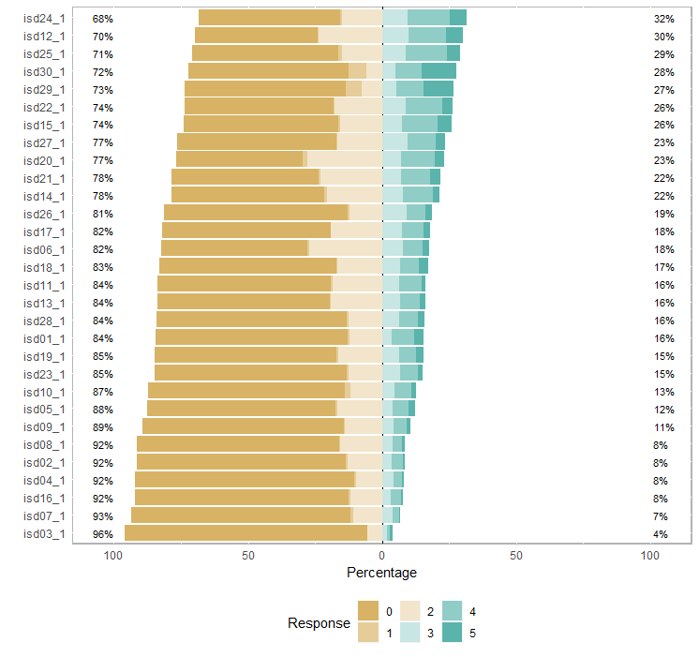

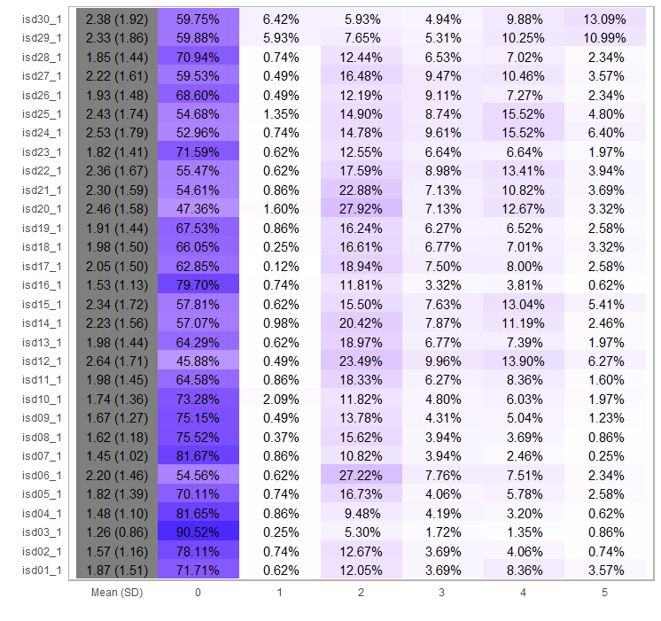

Descripción de ítems de la escala DSI a los 12 meses: N=650

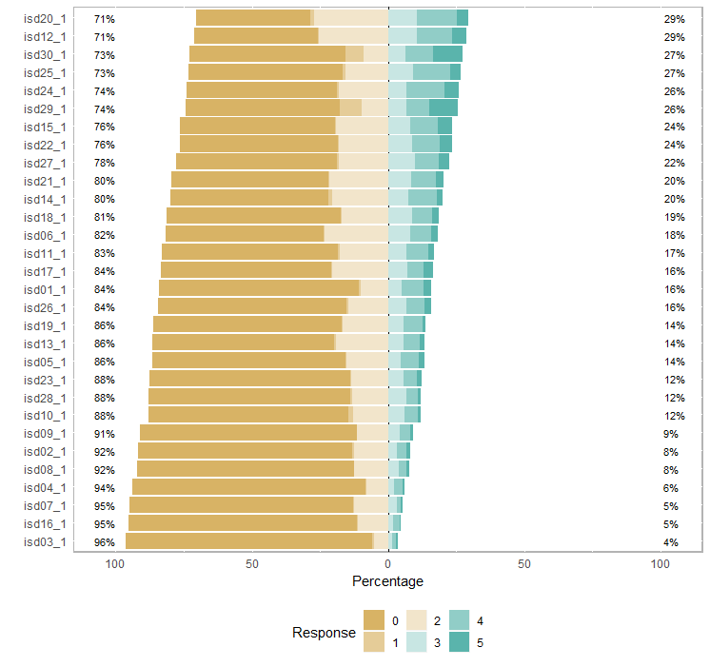

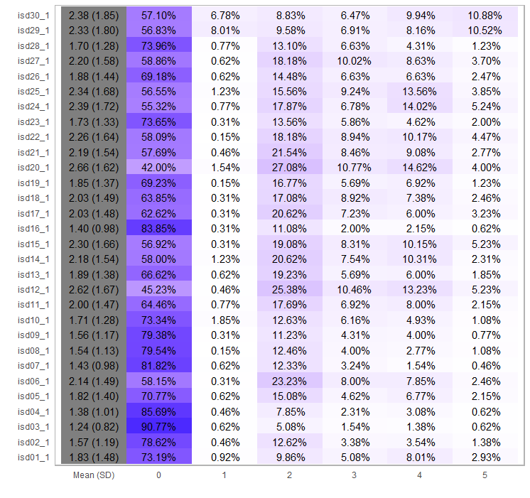

|  |  |  |  |  |
| --- | --- | --- | --- | --- |
|  |  | Moment | | |
|  |  | 1; N=977 | 2; N=813 | 3; N=642 |
| Number of symptoms | mean | 10.3 | 10.3 | 10 |
| sd | 6.6 | 6.7 | 6.6 |
| median | 9 | 9 | 9 |
| IQR | 10 | 10 | 9 |
| Symptom score | mean | 30.7 | 29.9 | 28.5 |
| sd | 22.3 | 32 | 21.7 |
| median | 26 | 26 | 23 |
| IQR | 32 | 30 | 31 |

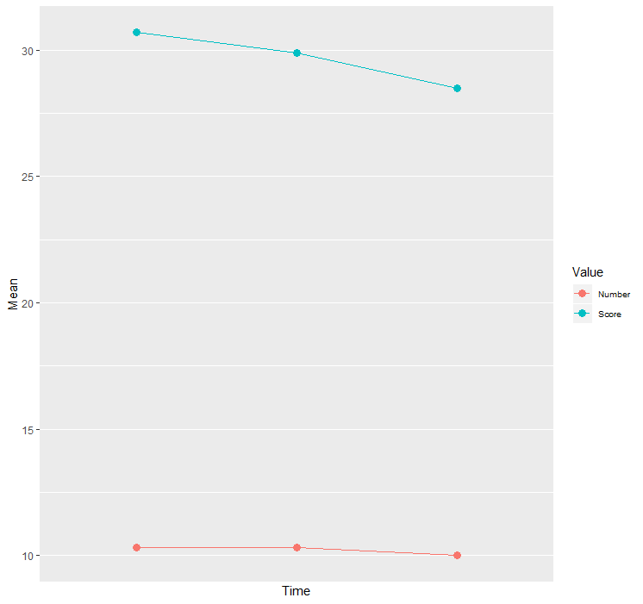

Se evaluó si el anterior cambio en el tiempo del número de síntomas y del puntaje de los síntomas es estadísticamente significativo; para esto se utilizaron pruebas de ANOVA de medidas repetidas, y pruebas de Friedman (teniendo en cuenta la asimetría de la variable “número de síntomas”). Los resultados se muestran a continuación:

. anova numsintom newid moment, repeated( moment)

Number of obs = 2440 R-squared = 0.7861

Root MSE = 3.97533 Adj R-squared = 0.6402

Source | Partial SS df MS F Prob > F

-----------+----------------------------------------------------

Model | 84201.0719 989 85.1375853 5.39 0.0000

|

newid | 84146.1469 987 85.2544548 5.39 0.0000

moment | 89.3051007 2 44.6525504 2.83 0.0596

|

Residual | 22914.6949 1450 15.8032379

-----------+----------------------------------------------------

Total | 107115.767 2439 43.9179036

Between-subjects error term: newid

Levels: 988 (987 df)

Lowest b.s.e. variable: newid

Repeated variable: moment

Huynh-Feldt epsilon = 0.9879

Greenhouse-Geisser epsilon = 0.9860

Box's conservative epsilon = 0.5000

------------ Prob > F ------------

Source | df F Regular H-F G-G Box

-----------+----------------------------------------------------

moment | 2 2.83 0.0596 0.0603 0.0604 0.0932

Residual | 1450

----------------------------------------------------------------

> friedman.test(repetidasdsilong$numsintom, repetidasdsilong$moment, repetidasdsilong$newid)

Friedman rank sum test

data: repetidasdsilong$numsintom, repetidasdsilong$moment and repetidasdsilong$newid

Friedman chi-squared = 4.038, df = 2, p-value = 0.1328

No se encuentran diferencias significativas en el tiempo (tanto el ANOVA de medidas repetidas como el Friedman dan valores p mayores que 0.05).

. anova scoresintom newid moment, repeated( moment)

Number of obs = 2440 R-squared = 0.7964

Root MSE = 13.1013 Adj R-squared = 0.6575

Source | Partial SS df MS F Prob > F

-----------+----------------------------------------------------

Model | 973447.279 989 984.274296 5.73 0.0000

|

newid | 971548.755 987 984.345243 5.73 0.0000

moment | 2375.15732 2 1187.57866 6.92 0.0010

|

Residual | 248885.343 1450 171.645064

-----------+----------------------------------------------------

Total | 1222332.62 2439 501.161386

Between-subjects error term: newid

Levels: 988 (987 df)

Lowest b.s.e. variable: newid

Repeated variable: moment

Huynh-Feldt epsilon = 0.9880

Greenhouse-Geisser epsilon = 0.9861

Box's conservative epsilon = 0.5000

------------ Prob > F ------------

Source | df F Regular H-F G-G Box

-----------+----------------------------------------------------

moment | 2 6.92 0.0010 0.0011 0.0011 0.0087

Residual | 1450

----------------------------------------------------------------

> friedman.test(repetidasdsilong$scoresintom, repetidasdsilong$moment, repetidasdsilong$newid)

Friedman rank sum test

data: repetidasdsilong$scoresintom, repetidasdsilong$moment and repetidasdsilong$newid

Friedman chi-squared = 6.3541, df = 2, p-value = 0.04171

Se encuentran diferencias significativas en el tiempo (tanto el ANOVA de medidas repetidas como el test de Friedman dan valores p menores que 0.05).

## Síndrome de piernas inquietas:

Para cada uno de los tres períodos de medición se estimó la proporción de diagnósticos de RLS. Los resultados se presentan en la siguiente tabla:

|  |  |  |  |  |  |  |  |
| --- | --- | --- | --- | --- | --- | --- | --- |
|  |  | Time 0. N=977 | | Time 1. N=818 | | Time 2 | |
|  |  | Freq. | Percent | Freq. | Percent | Freq. | Percent |
| RLS | 0 | 761 | 77.89 | 761 | 87.53 | 595 | 90.02 |
| 1 | 216 | **22.11** | 102 | **12.47** | 66 | **9.98** |
|  | Total | 977 | 100 | 818 | 100 | 661 | 100 |



. cochranq RLS_Dx_ id momento

Cochran's Q = 145.4229 with df = 2

Asymptotic test:

P(Q >= 145.4229) = 0.0000

Non-asymptotic test:

Z =71.853606

gamma = 1.9889

P(Q >= 145.4229) = 0.0683

Comparison of RLS_Dx_ by momento

(No adjustment)

Row vs. |

Column | 0 1

---------+----------------------

1 | 73.840909

| 0.0000

na | -58.4084

|

2 | 1.05e+02 11.172414

| 0.0000 0.0008

na | 0.2491 -7.3142

alpha = 0.05

Reject Ho if p <= alpha

Cochran's Q = 145.4229 with df = 2

Maximum-corrected effect size Q/[b(k-1)] = 0.0732

(per Serlin, Carr and Marascuillo)

Asymptotic test:

P(Q >= 145.4229) = 0.0000

Non-asymptotic test:

Z =71.853606

gamma = 1.9889

P(Q >= 145.4229) = 0.0683

Comparison of RLS_Dx_ by momento

(Sidák)

Row vs. |

Column | 0 1

---------+----------------------

1 | 73.840909

| 0.0000

na | -2.1e+05

|

2 | 1.05e+02 11.172414

| 0.0000 0.0025

na | 0.5765 -5.7e+02

Family-wise Error Rate = 0.05

Reject Ho if p <= FWER

**cochranq RLS_Dx_ id momento**

**cochranq RLS_Dx_ id momentocochranq RLS_Dx_ id momento**